**CLASSIFICATION OF ARRHYTHMIA BY USING DEEP LEARNING WITH 2-D ECG SPECTRAL IMAGE REPRESENTATION**

**A PROJECT REPORT**

***Submitted by***

**VISHUVARATHAN. V (950019106047)**

**PRAVIN KUMAR. D (950019106030)**

**RAMALINGAM. R (950019106032)**

**DHARUN. C (950019106008)**

***In partial fulfillment for the award of the degree of***

**TEAM ID: PNT2022TMID49645**

**BACHELOR OF ENGINEERING *IN***

**ELECTRONICS AND COMMUNICATION**

**ENGINEERING**



|  |  |  |  |
| --- | --- | --- | --- |
| **S.NO** | **TABLE OF CONTENT** | |  |
| **1** | **INTRODUCTION** | |  |
|  | 1.1 | Project Overview |  |
|  | 1.2 | Purpose |  |
| **2** | **LITERATURE SURVEY** | |  |
|  | 2.1 | Existing problem |  |
|  | 2.2 | Reference |  |
|  | 2.3 | Problem Statement Definition |  |
| **3** | **IDEATION & PROPOSED SOLUTION** | |  |
|  | 3.1 | Empathy Map Canvas |  |
|  | 3.2 | Ideation &Brainstorming |  |
|  | 3.3 | Proposed Solution |  |
|  | 3.4 | Problem Solution Fit |  |
| **4** | **REQUIREMENT ANALYSIS** | |  |
|  | 4.1 | Functional requirements |  |
|  | 4.2 | Non-Functional requirements |  |
| **5** | **PROJECT DESIGN** | |  |
|  | 5.1 | Data Flow Diagrams |  |
|  | 5.2 | Solution & Technical Architecture |  |
|  | 5.3 | User Stories |  |
| **6** | **PROJECT PLANNING & SCHEDULING** | |  |
|  | 6.1 | Sprint Planning & Estimation |  |
|  | 6.2 | Sprint Delivery Schedule |  |
|  | 6.3 | Reports from JIRA |  |
| **7** | **CODING & SOLUTIONING (Explain the features**   **added in the project along with code)** | |  |
|  | 7.1 | Feature 1 |  |
|  | 7.2 | Feature 2 |  |
|  | 7.3 | Database Scheme (if applicable) |  |
| **8** | **TESTING** | |  |
|  | 8.1 | Test Cases |  |
|  | 8.2 | User Acceptance Testing |  |
| **9** | **RESULT** | |  |
|  | 9.1 | Performance Metrics |  |
| **10** | **ADVANTAGES &DISADVANTAGES** | |  |
| **11** | **CONCLUSION** | |  |
| **12** | **FUTURE SCOPE** | |  |
| **13** | **APPENDIX** | |  |
|  |  | Source Code |  |
|  |  | GitHub & Project Demo Link |  |

**1.INTRODUCTION**

**1.1. PROJECT OVERVIEW**

The electrocardiogram (ECG) is one of the most extensively employed signals used in the diagnosis and prediction of cardiovascular diseases (CVDs). The ECG signals can capture the heart's rhythmic irregularities, commonly known as arrhythmias. A careful study of ECG signals is crucial for precise diagnoses of patients' acute and chronic heart conditions. We achieved a state-of-the-art average classification accuracy of 99.11%, which is better than those of recently reported results in classifying similar types of arrhythmias. The performance is significant in other indices as well, including sensitivity and specificity, which indicates the success of the proposed method.

**1.2. PURPOSE:**

To detect the arrhythmia in the early stage. For the early detection of arrhythmia, we proposed an 2-D spectral image representation method based on Deep learning model

**2.LITERATURE SURVEY**

**2.1.EXISTING METHOD:**

**Classification of Arrhythmia by Using Deep Learning with 2-D ECG Spectral Image Representation**

**Amin Ullah, Syed M. Anwar, Muhammad Bilal, Raja M Mehmood**

**In the year of 2020**

**Abstract**

The electrocardiogram (ECG) is one of the most extensively employed signals used in the diagnosis and prediction of cardiovascular diseases (CVDs). The ECG signals can capture the heart’s rhythmic irregularities, commonly known as arrhythmias. A careful study of ECG signals is crucial for precise diagnoses of patients’ acute and chronic heart conditions. In this study, we propose a two-dimensional (2-D) convolutional neural network (CNN) model for the classification of ECG signals into eight classes; namely, normal beat, premature ventricular contraction beat, paced beat, right bundle branch block beat, left bundle branch block beat, atrial premature contraction beat, ventricular flutter wave beat, and ventricular escape beat. The one-dimensional ECG time series signals are transformed into 2-D spectrograms through short-time Fourier transform. The 2-D CNN model consisting of four convolutional layers and four pooling layers is designed for extracting robust features from the input spectrograms. Our proposed methodology is evaluated on a publicly available MIT-BIH arrhythmia dataset. We achieved a state-of-the-art average classification accuracy of 99.11%, which is better than those of recently reported results in classifying similar types of arrhythmias. The performance is significant in other indices as well, including sensitivity and specificity, which indicates the success of the proposed method.

**Conclusions**

In this study, we proposed a 2-D CNN-based classification model for automatic classification of cardiac arrhythmias using ECG signals. An accurate taxonomy of ECG signals is extremely helpful in the prevention and diagnosis of CVDs. Deep CNN has proven useful in enhancing the accuracy of diagnosis algorithms in the fusion of medicine and modern machine learning technologies. The proposed CNN-based classification algorithm, using 2-D images, can classify eight kinds of arrhythmia, namely, NOR, VFW, PVC, VEB, RBB, LBB, PAB, and APC, and it achieved 97.91% average sensitivity, 99.61% specificity, 99.11% average accuracy, and 98.59% positive predictive value (precision). These results indicate that the prediction and classification of arrhythmia with 2-D ECG representation as spectrograms and the CNN model is a reliable operative technique in the diagnosis of CVDs. The proposed scheme can help experts diagnose CVDs by referring to the automated classification of ECG signals. The present research uses only a single-lead ECG signal. The effect of multiple lead ECG data to further improve experimental cases will be studied in future work

# **A review on deep learning methods for ECG arrhythmia classification**

# **Zahra Ebrahimi, Mohammad Loni, Masoud Daneshtalab, Arash Gharehbhagi**

# **In the year 2020**

# **Abstract**

Deep Learning (DL) has recently become a topic of study in different applications including healthcare, in which timely detection of anomalies on Electrocardiogram (ECG) can play a vital role in patient monitoring. This paper presents a comprehensive review study on the recent [DL methods](https://www.sciencedirect.com/topics/computer-science/deep-learning-method) applied to the ECG signal for the [classification](https://www.sciencedirect.com/topics/computer-science/classification) purposes. This study considers various types of the DL methods such as Convolutional Neural Network (CNN), Deep Belief Network (DBN), [Recurrent Neural Network](https://www.sciencedirect.com/topics/computer-science/recurrent-neural-network) (RNN), Long Short-Term Memory (LSTM), and Gated Recurrent Unit (GRU). From the 75 studies reported within 2017 and 2018, CNN is dominantly observed as the suitable technique for feature extraction, seen in 52% of the studies. DL methods showed high accuracy in correct classification of Atrial Fibrillation (AF) (100%), Supraventricular Ectopic Beats (SVEB) (99.8%), and Ventricular Ectopic Beats (VEB) (99.7%) using the GRU/LSTM, CNN, and LSTM, respectively.

**Conclusions**

The study presented results of a review on different methods for classifying arrhythmia on ECG signals. The objective of the review method was to investigate the most powerful Deep Learning methods detecting various types of arrhythmia. Technical details of the common methods were discussed. The GRU/LSTM, CNN, and LSTM, showed outstanding results for correct classification of Atrial Fibrillation, Supraventricular Ectopic Beats, and Ventricular Ectopic Beats, respectively. It is also concluded that the useof a proper type of Deep Learningmethod can considerably improve the classification performance for the corresponding application.

**2.2.REFERENCES:**

<https://www.researchgate.net/publication/341623436ClassificationofArrhythmiabyUsingDeepLearningwith2-DECGSpectralImageRepresentation>

<https://www.ncbi.nlm.nih.gov/pmc/articles/PMC8705269/>

<https://www.ahajournals.org/doi/10.1161/JAHA.121.023222>

**2.3.PROBLEM STATEMENT DEFINITION**

Mr. NarayanaRao is a 35year old man. He wants to verify weather he has arrythmia or not. He has his ECG scan for verification but has no time to consult a doctor. He wants to get better knowledge about the disease. He cared about his heart about which he think its weak. He decided to find the weather he is affected or not. NarayanaRao needs an immediate remedy from the disease & he wants to know which specialist to get consulted if he had Arrhythmia.

|  |  |
| --- | --- |
| Who does the problem affect? | Person who is suffering from arrhythmia (or) people who doesn’t have time to consult a doctor. |
| What are the boundaries of the problem? | Person who has a problem with their heart and does not have time to consult a doctor (or) for someone who is in an emergency |
| What is the issue? | If Arrhythmia has been left untreated for a long term it could be fatal (or) in some cases it even caused deaths in short term itself. |

|  |  |
| --- | --- |
| Where does the issue occur? | It affects the heart of a person affected with arrythmia. |
| Why is it important that we fix the problem? | According to the World Health Organization (WHO), cardiovascular diseases (CVDs) are the number one cause of death today. Over 17.7 million people died from CVDs in the year 2017 all over the world which is about 31% of all deaths, and over 75% of these deaths occur in low and middle-income countries. Arrhythmia is a representative type of CVD that refers to any irregular change from the normal  heart rhythms. |
| What is the solution to solve this issue? | Therapies to treat heart arrhythmias include vagal maneuvers and cardioversion to stop the irregular heartbeat, etc |

**3.IDEATION & PROPOSED SOLUTION**

**3.1.** EMPATHY MAP CANVAS

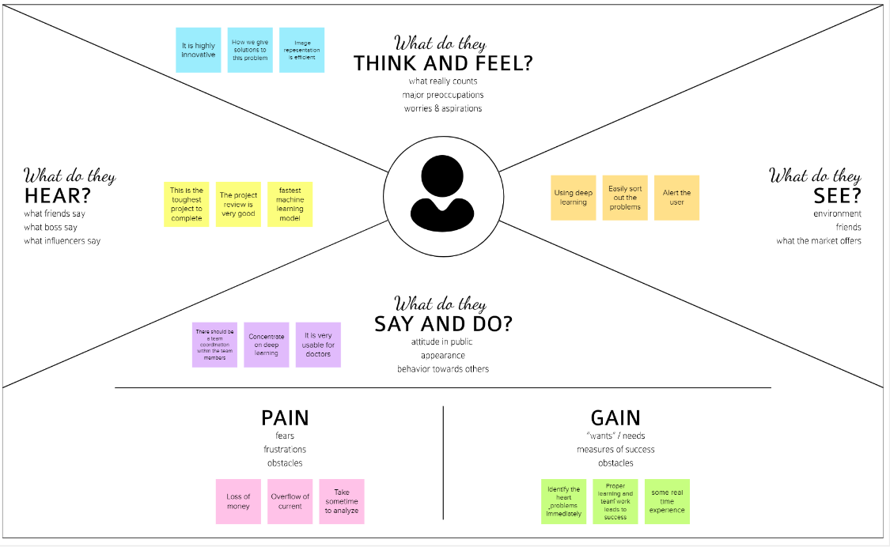

**3.2.BRAINSTORMING :**

**Problem Statements:**

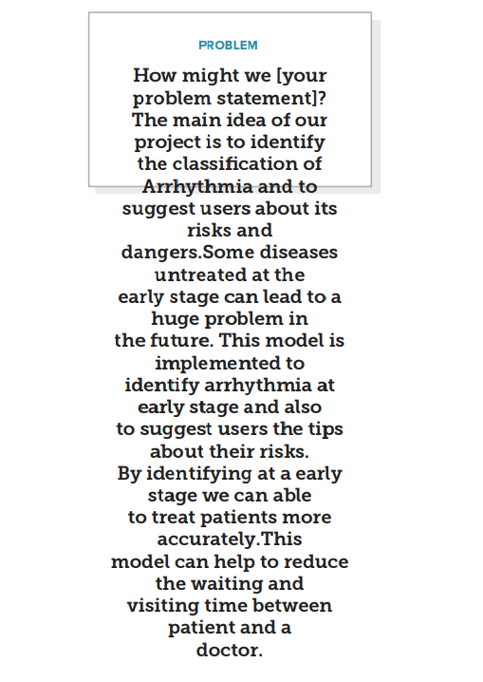

**Brainstorm:**

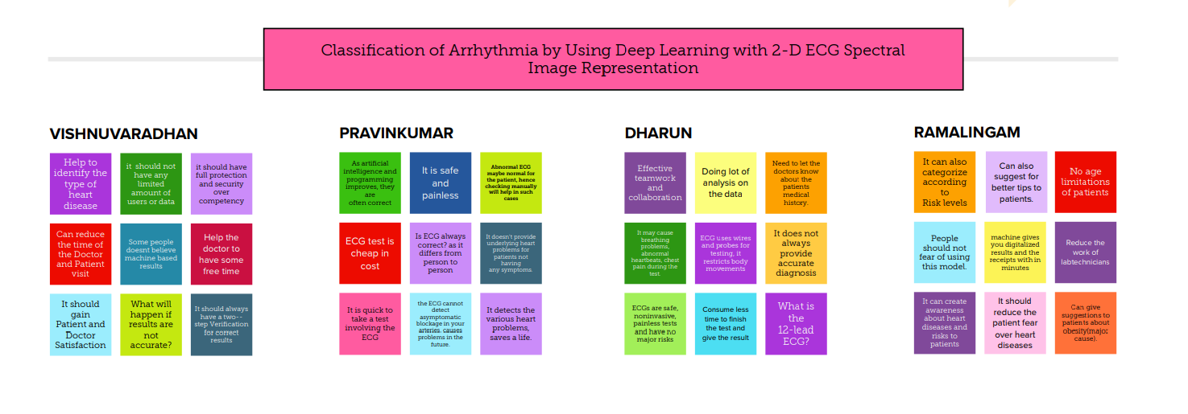**Group ideas**:

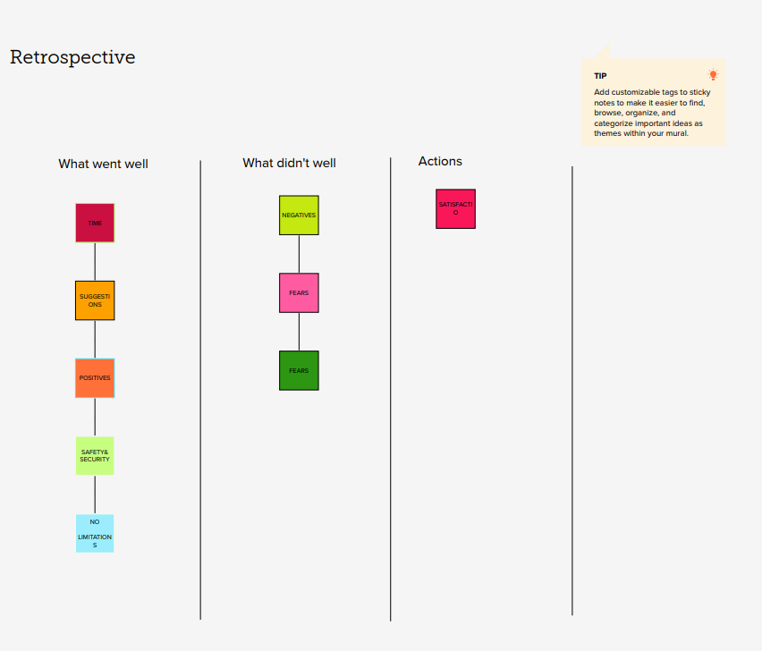

**Priortize:**

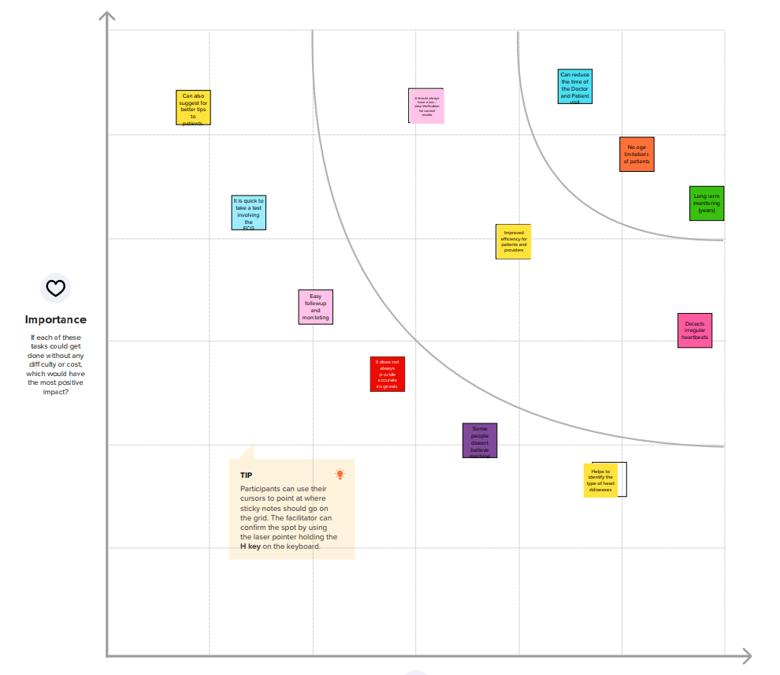

**3.3.PROPOSED SOLUTION:**

|  |  |  |
| --- | --- | --- |
| **S. No.** | **Parameter** | **Description** |
|  | Problem Statement (Problem to be solved) | 1.Electrocardiography (ECG) is a method for monitoring the human heart’s electrical activity.  2.ECG signal is often used by clinical experts in the collected time arrangement for the evaluation of any rhythmic circumstances of a topic.  3.The research was carried to make the assignment computerized by displaying the problem with encoder-decoder methods, by using misfortune appropriation to predict standard or anomalous information. |
|  | Idea / Solution description | 1.Electrocardiogram signals have been widely used to identify arrhythmias due to their non -invasive approach.  2.A better alternative is to utilize deep learning models for early automatic identification of cardiac arrhythmia, thereby enhancing diagnosis and treatment. |
|  | Novelty / Uniqueness | 1.When the cardiac arrhythmia problem occur, we can find out the pulse wave in minutes.  2. It is easy to find out the cardiac problem. |
|  | Social Impact / Customer Satisfaction | 1.This can reduce the arrhythmia problem in the beginning stage by the pulse wave.  2.The user can also use the as a surveillance.  3.By the way monitor the patient. |
|  | Business Model (Revenue Model) | 1.This application will be available in the multi- speciality hospital.  2.Government providing this type service. |
|  | Scalability of the Solution | 1.This application can monitor different phase simultaneously and can detect cardiac arrhythmia with high accuracy. |

**3.4.PROPOSED SOLUTION FIT:**

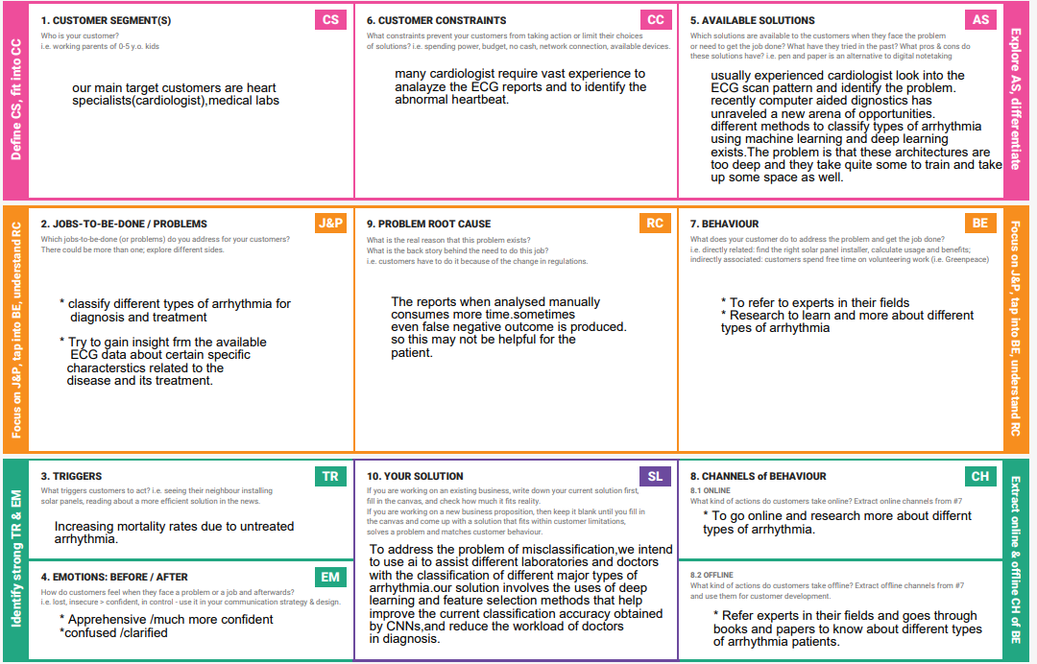

**4.REQUIREMENT ANALYSIS**

**4.1.FUNCTIONAL REQUIREMENTS:**

|  |  |  |
| --- | --- | --- |
| FR No. | Functional Requirement (Epic) | Sub Requirement (Story/Sub-Task) |
|  |  |  |
| FR-1 | User Registration | Registration through website using email |
|  |  | for verification |
|  |  |  |
| FR-2 | User Confirmation | Verification of the OTP on the website |
|  |  |  |
| FR-3 | User Data | Uploading of the ECG used for Arrhythmia |
|  |  | Diagnosis |
|  |  |  |
| FR-4 | User Diagnosis Results (Single Input) | Results of the Arrhythmia Prediction & |
|  |  | Classification displayed in the website |
|  |  |  |
| FR-5 | User Diagnosis Results (Multiple Input) | Results of the Arrhythmia |
|  |  | Prediction & Classification sent to |
|  |  | registered email |
|  |  |  |

.

**4.2.NON-FUNCTIONAL REQUIREMENTS.**

|  |  |  |
| --- | --- | --- |
| FR No. | Non-Functional Requirement (Epic) | Sub Requirement (Story/Sub-Task) |
|  |  |  |
| NFR-1 | Usability | Efficiency and overall satisfaction of the |
|  |  | user when using Diagnosis service through |
|  |  | website |
|  |  |  |
| NFR-2 | Security | Authentication and Authorization of the |
|  |  | website |
|  |  |  |
| NFR-3 | Reliability | Probability of successful operations for a |
|  |  | specified time in an environment |
|  |  |  |

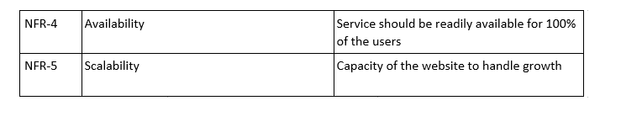**5.PROJECT DESIGN**

**5.1.DATA FLOW DIAGRAMS:**

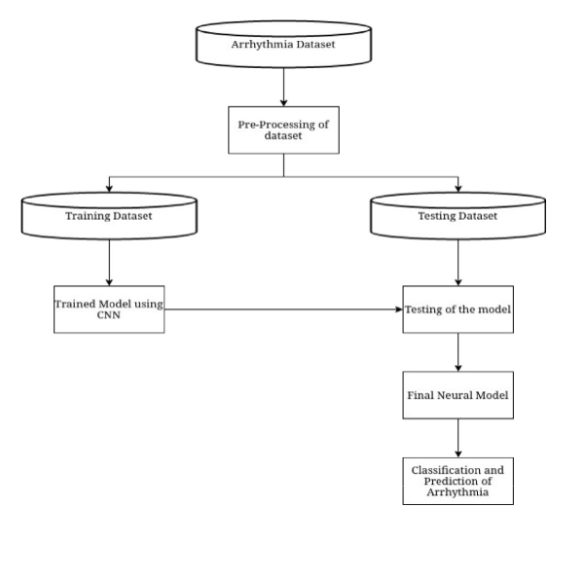

**?5.2.SOLUTION AND TECHNICAL ARCHIETECTURE:**

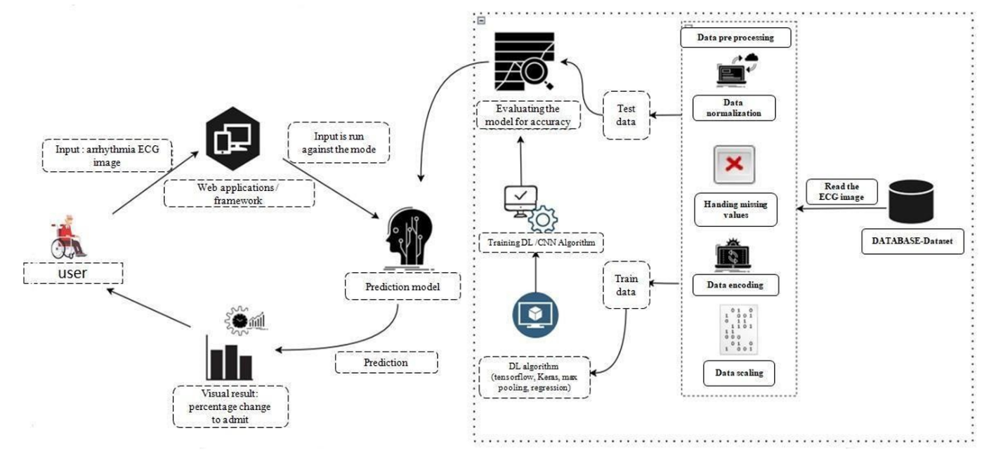

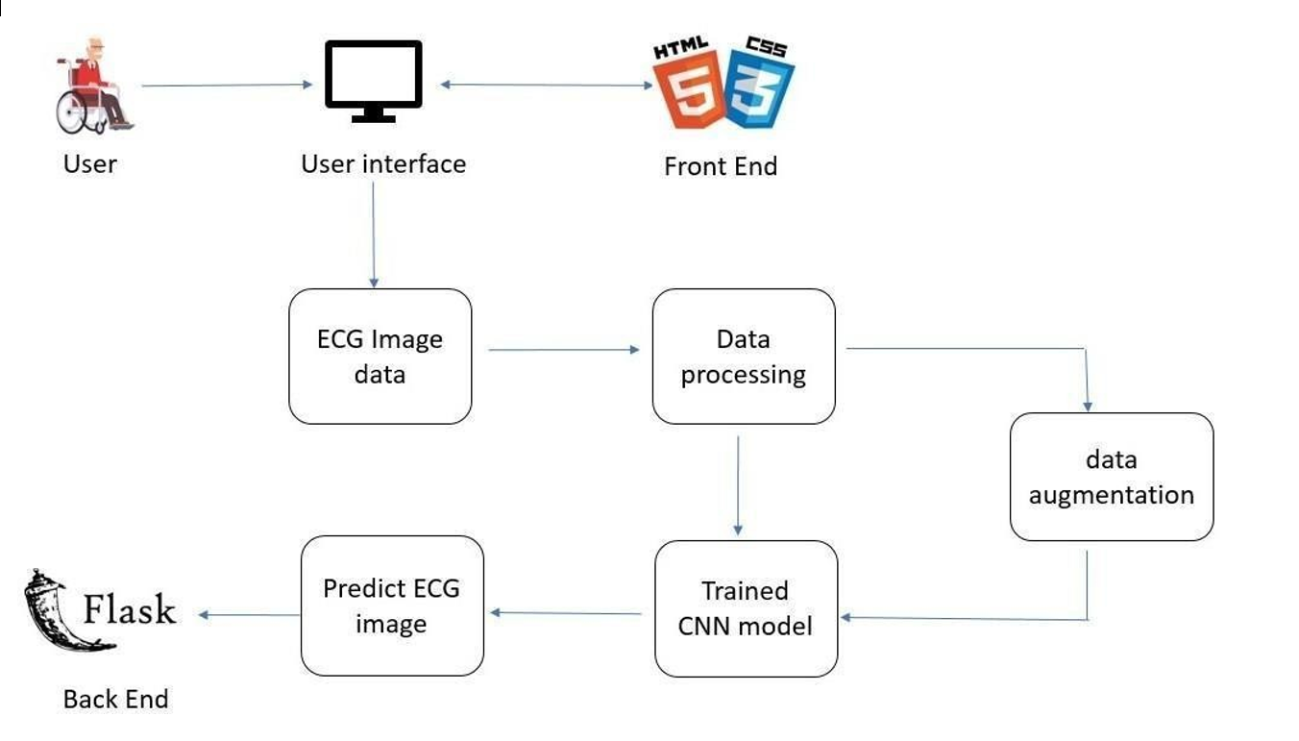

**5.3.USER STORIES:**

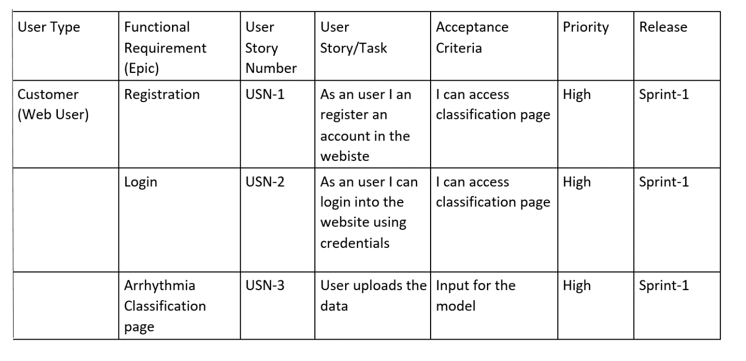

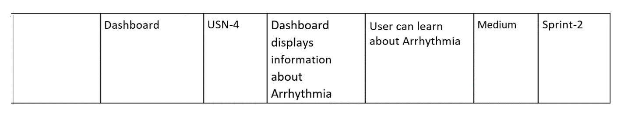

**6.PROJECT PLANNING & SCHEDULING:**

**6.1.SPRINT PLANNING & ESTIMATION:**

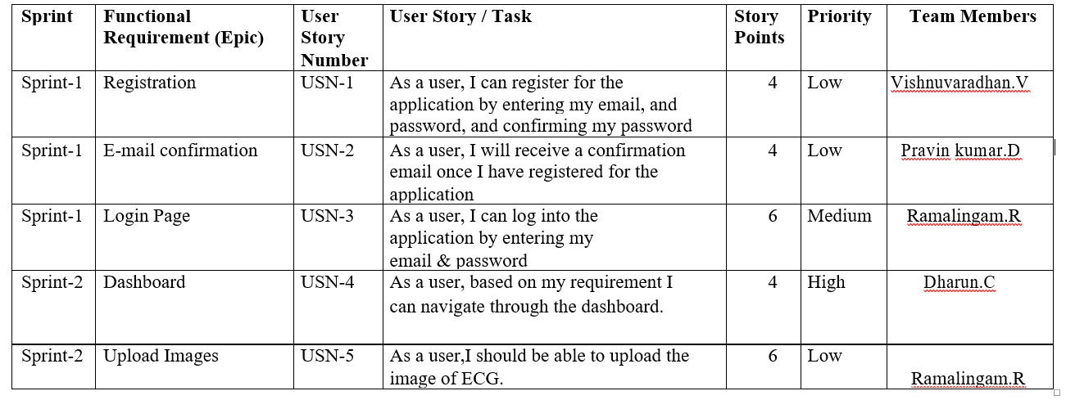

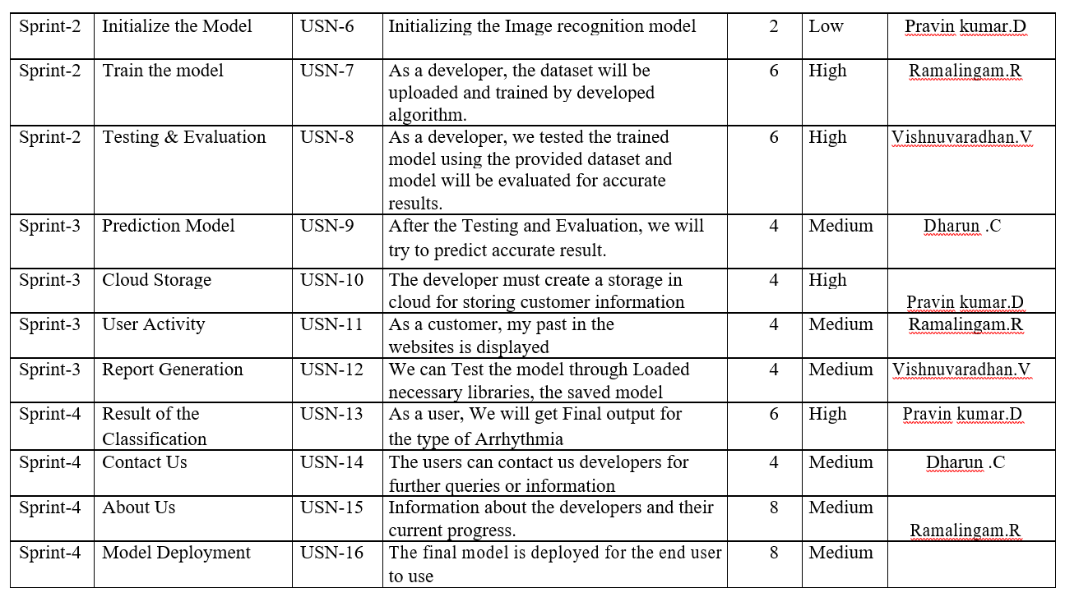

**MILESTONE & ACTIVITY LIST:**

|  |  |
| --- | --- |
| **Milestones** | **Activities** |
|  |  |
| Project development phase | Delivery of sprint- 1,2,3,4 |
|  |  |
| Create and configure and IBM cloud services | Create IBM Watson |
|  |  |
| Create and access deep learning | Create v1 to interact with app deploy |
|  |  |
|  | Create IBM and connect with python |
|  |  |
| Create & database in cloudant DB | Launch the cloudant DB and Create database |
|  |  |
| Develop the python flask | Install the python software |
|  |  |
|  |  |
| Create the web application | Develop the web application |
|  |  |
|  | To intensity and showcase on open CV window |
|  |  |

|  |  |  |
| --- | --- | --- |
| **Milestones** | **Activities** | **Description** |
|  |  |  |
| Ideation phase | literature | Literature survey on the selected |
|  |  | project & information gathering |
|  | Empathy Map | Prepare empathy map to capture |
|  |  | the user pains & gains, prepare |
|  |  | list of problem statement |
|  |  |  |

|  |  |  |
| --- | --- | --- |
|  | Ideation | Organizing the brainstorming |
|  |  | session and priorities the top 3 |
|  |  | ideas based on feasibility & |
|  |  | Importance |
| Project design phase I | Proposed solution | Prepare proposed solution |
|  |  | document which includes |
|  |  | novelty, feasibility of ideas, |
|  |  | business model, social |
|  |  | impact, |
|  |  | scalability of solution |
|  | Problem solution fit | Prepare solution fit document |
|  |  |  |
|  | Solution Architecture | Prepare solution architecture |
|  |  | Document |
| Project Design Phase II | Customer journey | Prepare customer journey map |
|  |  | to understand the user |
|  |  | interaction & experience with |
|  |  | the application |
|  | Functional requirement | Prepare functional & non |
|  |  | functional requirement |
|  |  | Document |
|  | Data flow diagram | Prepare Data flow Diagram |
|  |  |  |
|  | Technology Architecture | Draw the technology |
|  |  | architecture diagram |
|  |  |  |
| Project planning phase | Milestones & Activity list | Prepare milestones and activity |
|  |  | list of the project |
|  | Sprint delivery plan | Prepare sprint delivery plan |
|  |  |  |
| Create and configure and IBM | Create IBM cloud account | IBM cloud account created |
| cloud services |  | successfully by all the members |

**6.2.SPRINT DELIVERY SCHEDULE:**

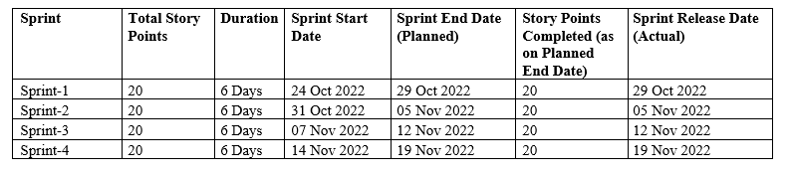

**6.3.REPORTS FROM JIRA:**

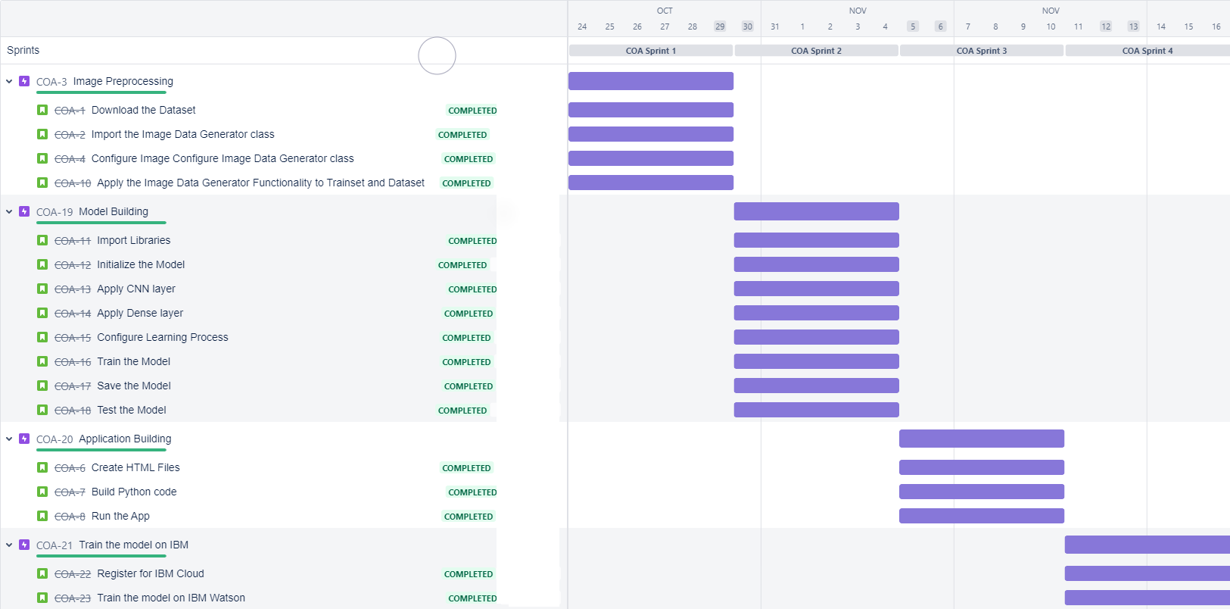

**7.CODING & SOLUTIONING**

**7.1.FEATURE 1:**

**1. CONVOLUTION NEURAL NETWORK:**

A CNN is a kind of network architecture for deep learning algorithms and is specifically used for image recognition and tasks that involve the processing of pixel data. There are other types of neural networks in deep learning, but for identifying and recognizing objects, CNNs are the network architecture of choice. The layers used in the CNN algorithm is Convolutional ,maxpooling, and flatten layer.

**2. Convolutional Layer:**

A convolutional layer is the main building block of a CNN. It contains a set of filters (or kernels), parameters of which are to be learned throughout the training. The size of the filters is usually smaller than the actual image. Each filter convolves with the image

Convolution layer is used for a image processing to blur and sharpen images, but also to perform other operations.

from keras.layers import Convolution2D

**3. Deep Neural Network**

A simple DNN contains multiple hidden layers that can process the input to output layers [60]. The DNN can recognize different kinds of unstructured data. In arrhythmia classification, authors proposed different kinds of neural networks but the proposed network is composed of the same components: neuron, weight, bias, and function. All these components are capable and act just like the human brain. The deep neural network is widely recognized approach for ECG image classification.

**Feature 2:**

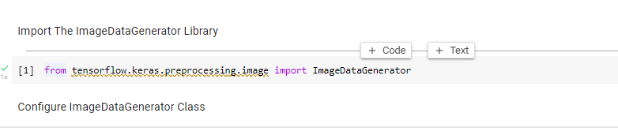

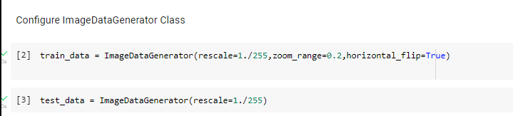

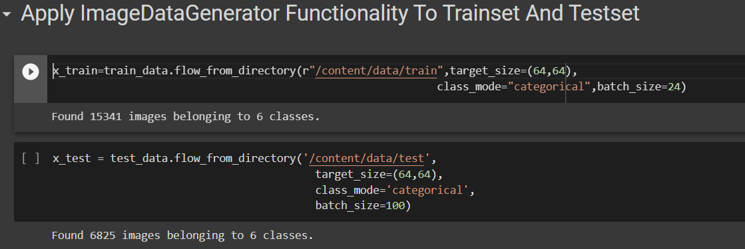

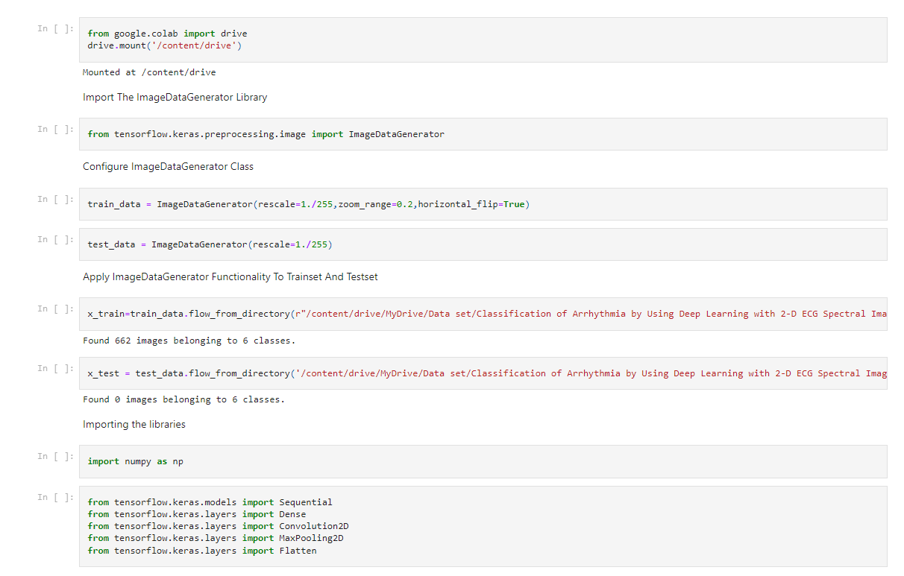

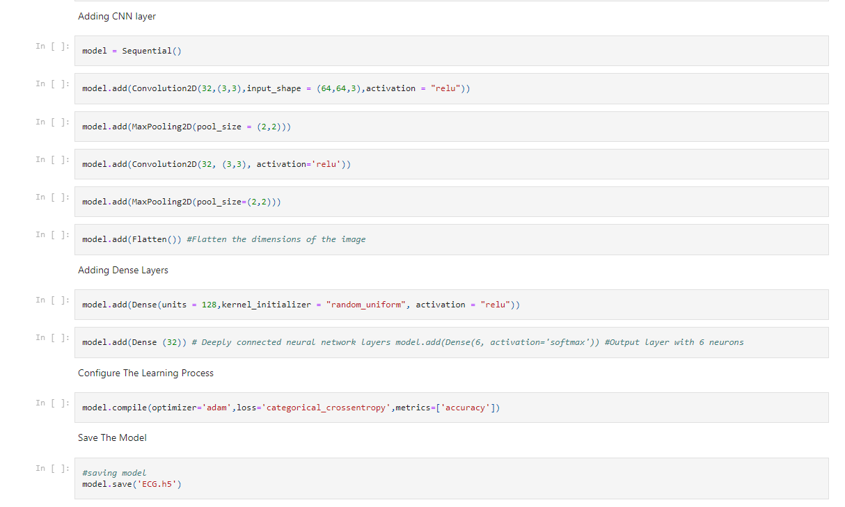

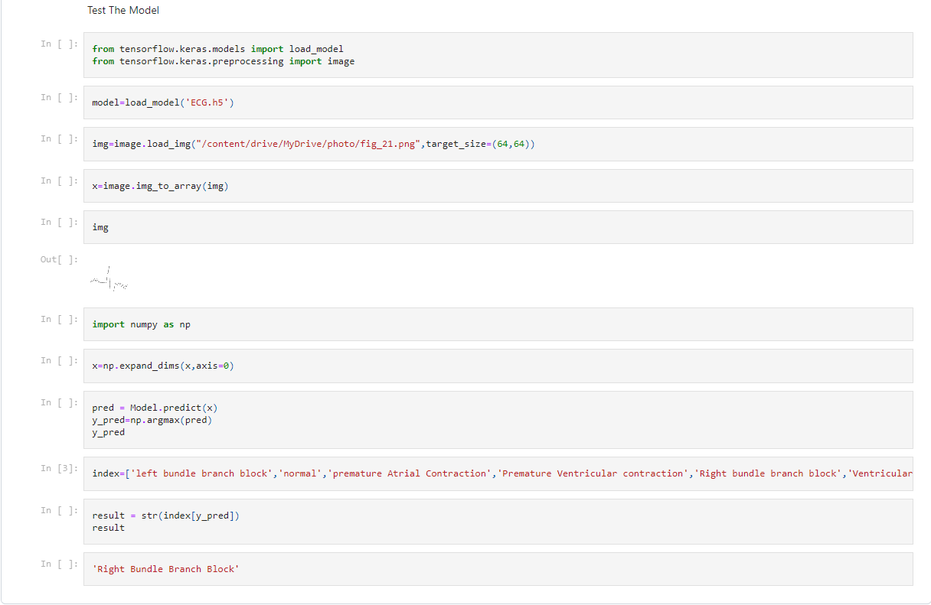

**8.TESTING**

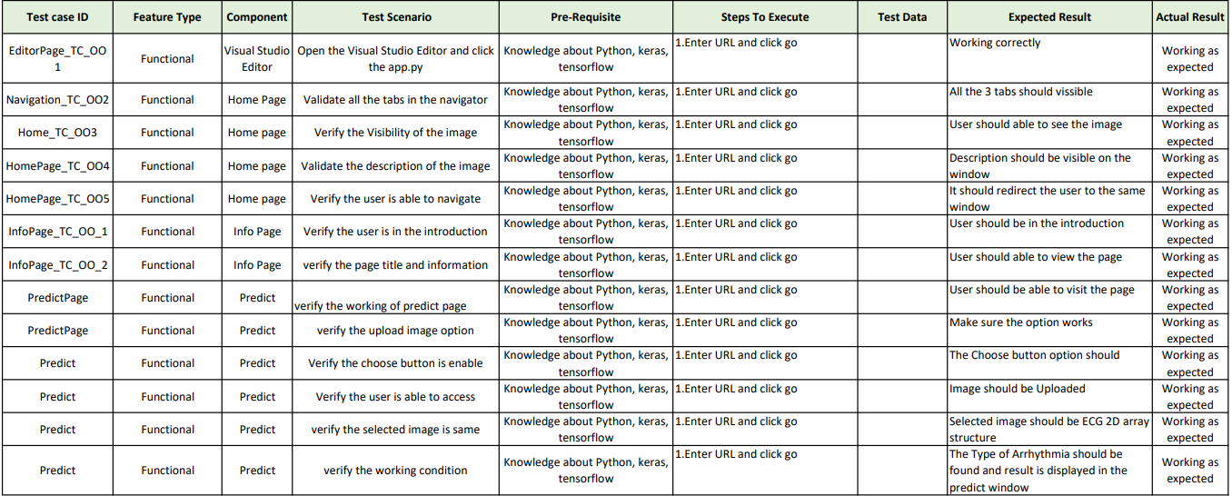Test Case Analysis:



**9.RESULTS**

**9.1.PERFORMANCSE METRICS:**

The two significant optimization parameters in the proposed 2-D CNN model are the learning rate and the batch size of the data used. To improve the performance, these two optimization parameters must be selected carefully to obtain the best accuracy in the automatic classification of arrhythmia using the ECG signals. The proposed model was evaluated in different experiments with various values of learning parameters. For a smaller value of the learning rate (i.e., less than 0.0005), the speed of the convergence was very slow. However, when the value of the learning rate was large (i.e., greater than 0.001), the speed of convergence improved. At the same time, asymmetrical changes were observed in the accuracy rate. Henceforth, we selected an optimum value of 0.001 for the learning rate, as this value can attain better accuracy for the proposed model.

10.ADVANTAGES & DISADVANTAGES

**ADVANTAGES:**

1.Ability to predict to correct and quickly.

2.The average classification accuracy of 99.11%.

3.Reliability – The model is very effective, inexpensive and easy to apply.

4.The model shows the classification of images accurately.

**DISADVANTAGES:**

1.The limited learning and perception ability of individual learners is not

sufficient to make them perform well in complex tasks.

2.Proper connectivity and maintenance will be a complex task.

**11.CONCLUSION**

In this study, we proposed a 2-D CNN-based classification model for automatic classification of cardiac arrhythmias using ECG signals. An accurate taxonomy of ECG signals is extremely helpful in the prevention and diagnosis of CVDs. Deep CNN has proven useful in enhancing the accuracy of diagnosis algorithms in the fusion of medicine and modern machine learning technologies. The proposed CNN-based classification algorithm, using 2-D images, can classify eight kinds of arrhythmia, namely, NOR, VFW, PVC, VEB, RBB, LBB, PAB, and APC, and it achieved 97.91% average sensitivity, 99.61% specificity, 99.11% average accuracy, and 98.59% positive predictive value (precision). These results indicate that the prediction and classification of arrhythmia with 2-D ECG representation as spectrograms and the CNN model is a reliable operative technique in the diagnosis of CVDs. The proposed scheme can help experts diagnose CVDs by referring to the automated classification of ECG signals. The present research uses only a single-lead ECG signal. The effect of multiple lead ECG data to further improve experimental cases will be studied in future work

**12.FUTURE SCOPE**

* ECE signals are waveforms that denote the electrical movement of the human hearts(P,QRS, and T).
* An electrocardiogram(ECG) is an important diagnostic tool for the assessment of cardiac arrhythmias in clinical routine.
* Artificial neural network based methods for classifying ECG arrhythmias are relatively new.

**13.APPENDIX**

**SOURCE CODE:**

Our project source code link: <https://colab.research.google.com/drive/10ZD-E4bmzimsLokmlcJWdhPv42m5GaSa?usp=sharing>

Our Github link **-** [**https://github.com/IBM-EPBL/IBM-**Project**-43175-1660713847**](https://github.com/IBM-EPBL/IBM-Project-43175-1660713847)

**DEMO VIDEO:**

Demo video link - <https://youtu.be/b9-SaSxWW3E>